**Project Name: Antique Item Gallery**

**Project Member:**

**Saurabh Gosavi 210543181028**

**Shubham Shete 210543181105**

**Paresh Bhoi 210543181059**

**Sumit Dhanegaonkar 210543181022**

**Abstract:**

The business-to-consumer aspect of product is the most visible business use of the World Wide Web. The primary goal of a site is to sell goods online.

This project deals with developing a website for Online Antique Items Sale. It provides the user with a catalog of different antique items available for purchase in the store. In order to facilitate online purchase an web application is provided to the user. The system is implemented using a 3-tier approach, with a backend database, a middle tier of SpringBoot, Hibernate and a web browser as the front end client. In order to develop a website, a number of Technologies must be studied and understood.

These include multi-tiered architecture, server and client side scripting techniques, implementation technologies such as JAVA(OOP), SpringBoot, Hibernate, JQUERY, BOOTSTRAP, HTML5, relational database (MySQL).

**Implementation Technologies:**

1. **Spring Boot Framework:**

Spring Boot is an open source Java-based framework used to create a micro Service. It is developed by Pivotal Team and is used to build stand-alone and production ready spring applications.

Spring Boot provides a good platform for Java developers to develop a stand-alone and production-grade spring application that you can **just run**. You can get started with minimum configurations without the need for an entire Spring configuration setup.

**1.1 Features of Spring Framework:**

## **Admin Support**

Spring Boot provides the facility to enable admin related features for the application. It is used to access and manage application remotely. We can enable it by simply using spring.application.admin.enabled property.

## **Externalized Configuration**

Spring Boot allows us to externalize our configuration so that we can work with the same application in different environments. Application use YAML files to externalize configuration.

## **Properties Files**

Spring Boot provides rich set of Application Properties. So, we can use that in properties file of our project. Properties file is used to set properties like: **server-port = 8082** and many others. It helps to organize application properties.

## **YAML Support**

It provides convenient way for specifying hierarchical configuration. It is a superset of JSON. The SpringApplication class automatically support YAML. It is successful alternative of properties.

## **Type-safe Configuration**

Strong type-safe configuration is provided to govern and validate the configuration of application. Application configuration is always a crucial task which should be type-safe. We can also use annotation provided by this library.

## **Logging**

Spring Boot uses Common logging for all internal logging. Logging dependencies are managed by default. We should not change logging dependencies, if there is no required customization is needed.

## **Security**

Spring Boot applications are spring bases web applications. So, it is secure by default with basic authentication on all HTTP endpoints. A rich set of Endpoints are available for develop a secure Spring Boot application.

**1.2 Advantages of Spring Framework:**

1. Spring Framework can be employed on all architectural layers used in the development of web applications
2. Uses the very lightweight POJO model when writing classes;
3. Allows you to freely link modules and easily test them;
4. Supports declarative programming;
5. Eliminates the need to independently create factory and singleton classes;
6. Supports various configuration methods;
7. Provides middleware-level service.
8. **The JDBC Template**

The central class of the Spring JDBC abstraction framework is the **JdbcTemplate** class that includes the most common logic in using the JDBC API to access data, such as handling the creation of connection, statement creation, statement execution, and release of resource. The**Jdbc-Template**class can be found in the **org.springframework.jdbc.core**package.

The **JdbcTemplate** class instances are thread-safe once configured. A single **JdbcTemplate** can be configured and injected into multiple DAOs.

We can use the **JdbcTemplate** to execute the different types of SQL statements. **Data Manipulation Language** (**DML**) is used for inserting, retrieving, updating, and deleting the data in the database such as **SELECT**, **INSERT**, or **UPDATE** statements

**2.1** **MySQL**

MySQL, the most popular Open Source SQL database management system, is developed, distributed, and supported by Oracle Corporation.

**Features of MySQL:**

* **MySQL is a database management system.**

A database is a structured collection of data. It may be anything from a simple shopping list to a picture gallery or the vast amounts of information in a corporate network. To add, access, and process data stored in a computer database, you need a database management system such as MySQL Server. Since computers are very good at handling large amounts of data, database management systems play a central role in computing, as standalone utilities, or as parts of other applications.

* **MySQL databases are relational.**

A relational database stores data in separate tables rather than putting all the data in one big storeroom. The database structures are organized into physical files optimized for speed. The logical model, with objects such as databases, tables, views, rows, and columns, offers a flexible programming environment.

* **MySQL software is Open Source.**

Open Source means that it is possible for anyone to use and modify the software. Anybody can download the MySQL software from the Internet and use it without paying anything.

* **The MySQL Database Server is very fast, reliable, scalable, and easy to use.**

MySQL Server was originally developed to handle large databases much faster than existing solutions and has been successfully used in highly demanding production environments for several years. Although under constant development, MySQL Server today offers a rich and useful set of functions. Its connectivity, speed, and security make MySQL Server highly suited for accessing databases on the Internet.

* **MySQL Server works in client/server or embedded systems.**

The MySQL Database Software is a client/server system that consists of a multithreaded SQL server that supports different back ends, several different client programs and libraries, administrative tools, and a wide range of application programming interfaces (APIs).

1. **Hardware and Software Requirements (Minimum):**

**Hardware:**

1. Intel i3 processor 3rd generation or later / AMD Ryzen 200 2nd generation or later

2. 2 GB ddr3 ram.

3. Windows 7 Home edition or later.

4. 200 GB Sata HDD Space

5. Data Connection 200 kbps

**Software:**

1. Eclipse 4.7 Oxygen
2. MySQL 5.7 with Workbench 8.0
3. Google Chrome version 79.0
4. Apache Tomcat Server 8.5
5. Maven Dependencies
6. **ER Diagram:**

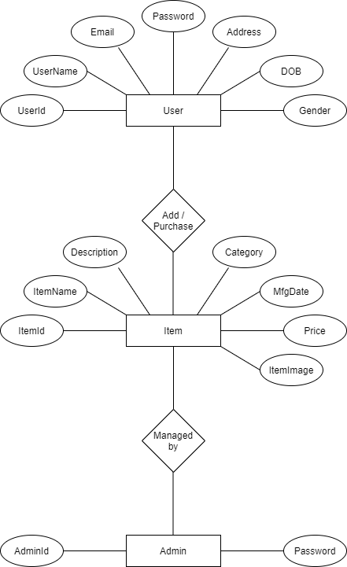

Figure 1: ER Diagram

1. **Table Structures:**
2. **Table name: admin_user**

**Column name Type NULL KEY DEFAULT**

userid varchar(255) NO PRI NULL

pwd varchar(255) YES NULL

1. **Table name:Customer**

**Column name Type NULL KEY DEFAULT**

Userid varchar(255) NO PRI NULL

dob varchar(255) YES NULL

email varchar(255) YES NULL

fname varchar(255) YES NULL

gender varchar(255) YES NULL

lname varchar(255) YES NULL

pwd varchar(255) YES NULL

1. **Table name:product**

**Column name Type NULL KEY DEFAULT**

prodid int NO PRI NULL

catid int NO MUL NULL

company varchar(255) YES NULL

deleted bit NO NULL

expirydate date YES NULL

mfgdate date YES NULL

pic varchar(255) YES NULL

pname varchar(255) YES NULL

price float NO NULL

qty int NO NULL

category_catid int YES MUL NULL

1. **Table name:category**

**Column name Type NULL KEY DEFAULT**

catid int NO PRI NULL

catname varchar(255) YES NULL

1. **Table name:cart**

**Column name Type NULL KEY DEFAULT**

id int NO PRI NULL

prodid int NO MUL NULL

qty int NO

userid varchar(255) YES MUL

1. **Table name:orders**

**Column name Type NULL KEY DEFAULT**

id int NO PRI NULL

cardno varchar(255) YES NULL

nameoncard varchar(255) YES NULL

orderdate datetime YES NULL

status varchar(255) YES NULL

userid varchar(255) YES MUL NULL

1. **Table name:order_details**

**Column name Type NULL KEY DEFAULT**

id int NO PRI NULL

orderid int NO MUL NULL

price float NO NULL

prodid int NO NULL

qty int NO NULL

order_id int YES MUL NULL

product_prodid int YES MUL NULL

1. **Table name:help_desk**

**Column name Type NULL KEY DEFAULT**

id int NO PRI NULL

date datetime YES NULL

description varchar(255) YES NULL

reply varchar(255) YES NULL

status varchar(255) YES NULL

subject varchar(255) YES NULL

userid varchar(255) YES MUL NULL

1. **UML Diagrams:**

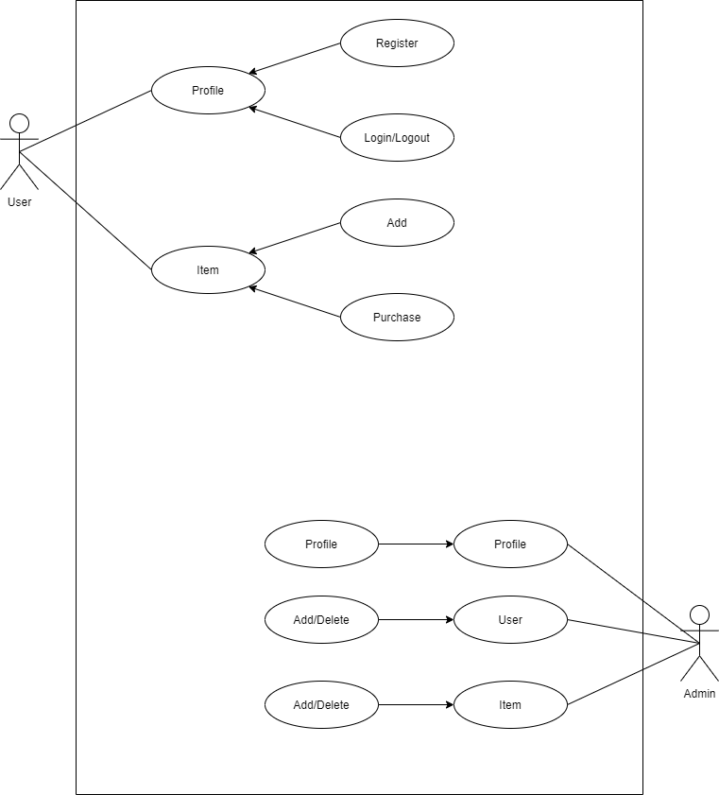

Figure 2: Use Case

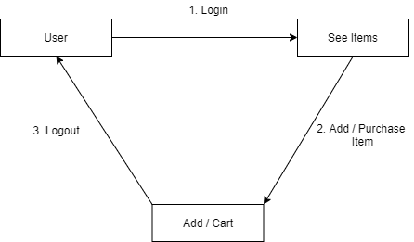

Figure 3: Collaboration Diagram

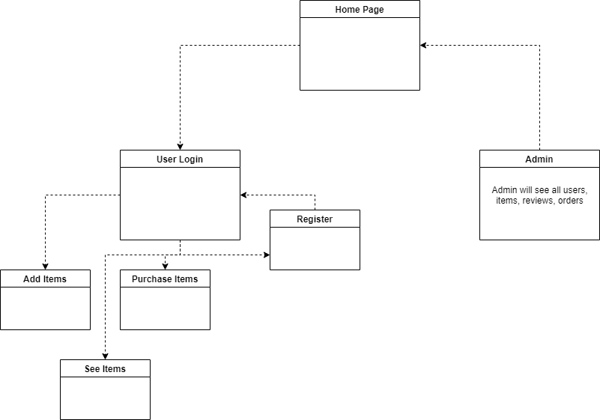

Figure 4: Component Diagram

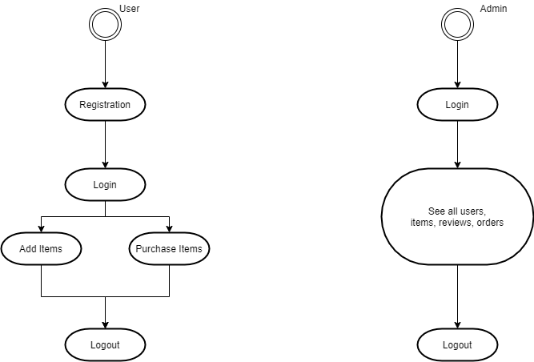

Figure 6: State Diagram

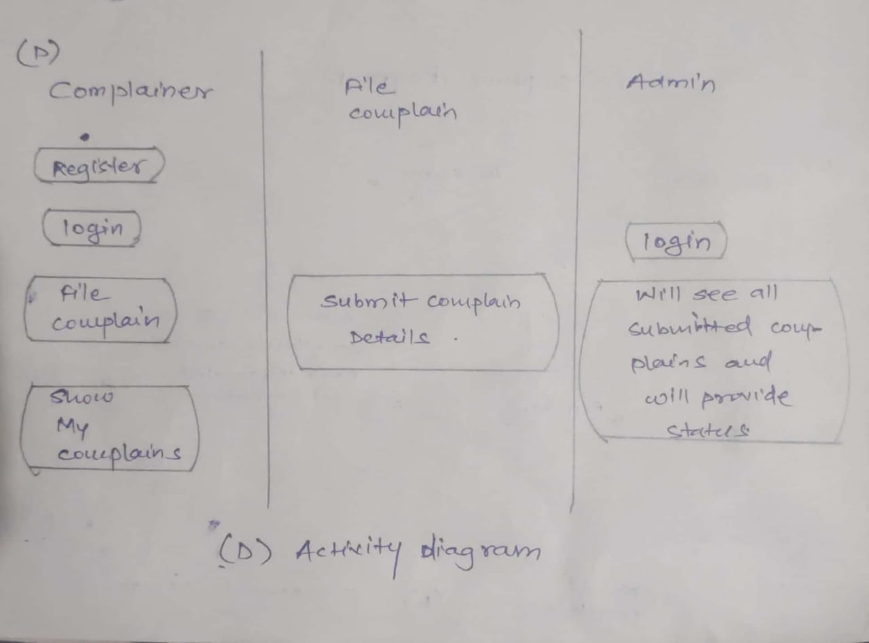

Figure 7: Activity Diagram

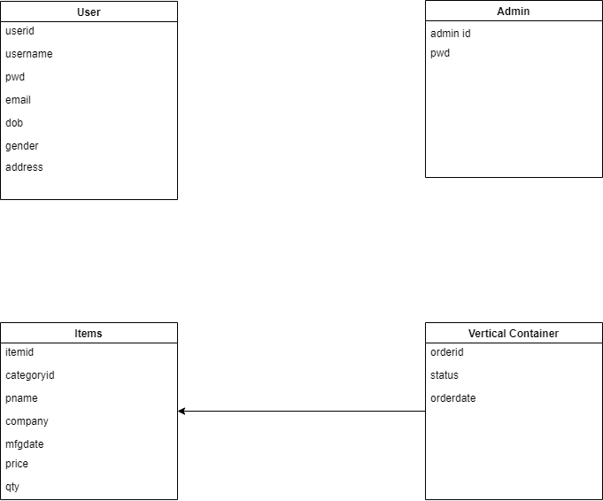

Figure 8: Class Diagram

1. **End to End Flow of Application:**

**User:**

* 1. User will login to the website or will have to register if he is not a registered user.
  2. After registration User will login and Dashboard page will be displayed to him which will display the items.
  3. From that page if User will click on the ‘**add to cart’** button of item. Item will get add to cart.
  4. If user will click on cart button of navbar then user able to do payment and user is able to purchse item successfully.
  5. A ‘**Help desk’** will be displayed on the navbar. From that user able to send review to admin.
  6. A category seletion will help to display items which will sorted by selected category
  7. A **‘Product’** helps to add new product as well as new category

**Admin:**

1. Admin will login as Admin from the ‘**Admin login**’ page and will be able to see products, user, categories and orders.
2. Admin can Review the review and after understanding it Admin will able to give reply on the review.
3. Admin can see the new orders. And admin will confirm that order after checking payment status .
4. It is the job of Admin to see new orders, items, users as well as reviews from user and manage all data.

1. **Future Scope of Project**
   1. Bidding option.
   2. Users can signup / login using their social media account such as Facebook.
   3. Add more feature in admin panel**.**
   4. E-mail Services.

**Thank You!**